#6

a.



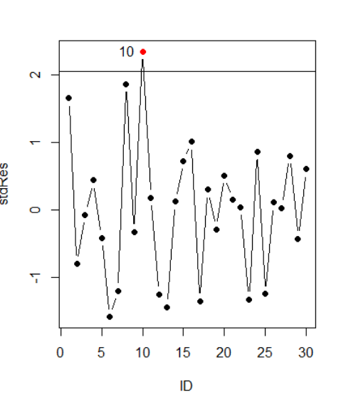

Yes, there have a team that should be considered as outliers when we do the standardized residuals. It is Oakland Athletics.

b.

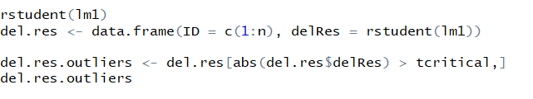

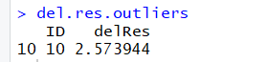

Yes, after studentized residual or studentized deleted residual, Oakland Athletics still should be considered as outliers.

c.

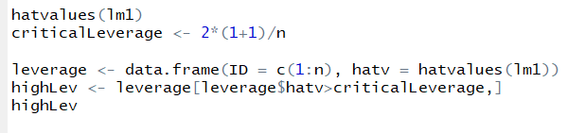

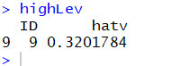

After identifying High Leverage Observations, New York Yankees should be considered as should be considered as high leverage point.

d.

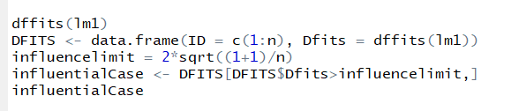

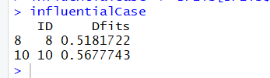

When we plot the DFITS, we know the Minnesota Twins and Oakland Athletics should be considered as influential to single fitted values

e.



There are no team should be considered as influential observations to all fitted values.

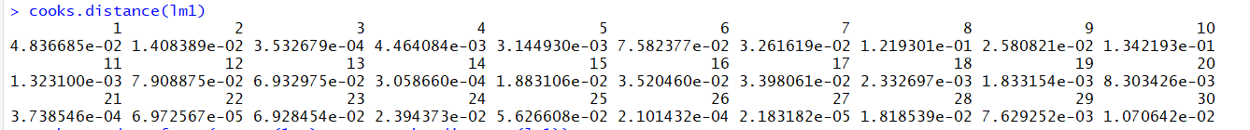

**f.**

**From** standardized residuals aspect, studentized residual aspect and DFITS aspect, we know Oakland Athletics could win more than expected given the size of their payroll.

Through High Leverage Observations, New York Yankees is a worse team, they lose more than expected given the size of their payroll.

Through DFITS, we also know Minnesota Twins is a good team.